**VIVEKANAND EDUCATION SOCIETY’S INSTITUTE OF TECHNOLOGY**

**An Autonomous Institute Affiliated to University of Mumbai**

**Department of Computer Engineering**



Project Report on

Electoral Insight 2024: Unveiling India’s

Future Political Landscape

In partial fulfillment of the Fourth Year, Bachelor of Engineering (B.E.) Degree in Computer Engineering at the University of Mumbai Academic Year 2023-24

**Submitted by**

Deanna Fernandes (D17 - B , Roll no - 24)

Nishtha Batra (D17 - B , Roll no - 07)

Prerna Bajaj (D17 - B , Roll no - 03)

Soham Bhole (D17 - B , Roll no - 10)

**Project Mentor**

Mrs. Abha Tewari

(2023-24)

**VIVEKANAND EDUCATION SOCIETY’S INSTITUTE OF TECHNOLOGY**

**An Autonomous Institute Affiliated to University of Mumbai**

**Department of Computer Engineering**



**Certificate**

This is to certify that ***Deanna Fernandes , Nishtha Batra , Prerna Bajaj , Soham Bhole*** of Fourth Year Computer Engineering studying under the University of Mumbai have satisfactorily completed the project on “***Electoral Insight 2024: Unveiling India’s Future Political Landscape***” as a part of their coursework of PROJECT-II for Semester-VIII under the guidance of their mentor ***Prof. Abha Tewari*** in the year 2023-24 .

This project report entitled ***Electoral Insight 2024: Unveiling India’s Future Political Landscape*** by ***Deanna Fernandes , Nishtha Batra , Prerna Bajaj , Soham Bhole***  is approved for the degree of **B.E Computer Engineering.**

| Programme Outcomes | Grade |
| --- | --- |
| PO1,PO2,PO3,PO4,PO5,PO6,PO7,  PO8, PO9, PO10, PO11, PO12  PSO1, PSO2 |  |

Date:

Project Guide:

------------------------------------------

**Project Report Approval**

**For**

**B. E (Computer Engineering)**

This project report entitled ***Electoral Insight 2024: Unveiling India’s Future Political Landscape*** by ***Deanna Fernandes , Nishta Batra , Prerna Bajaj , Soham Bhole*** is approved for the degree of **B.E Computer Engineering.**

Internal Examiner

---------------------------------------------

External Examiner

---------------------------------------------

Head of the Department

-----------------------------------------------

Principal

-----------------------------------------------

Date:

Place:

**Declaration**

We declare that this written submission represents our ideas in our own words and where others' ideas or words have been included, we have adequately cited and referenced the original sources. We also declare that we have adhered to all principles of academic honesty and integrity and have not misrepresented or fabricated or falsified any idea/data/fact/source in our submission. We understand that any violation of the above will be cause for disciplinary action by the Institute and can also evoke penal action from the sources which have thus not been properly cited or from whom proper permission has not been taken when needed.

| -----------------------------------------  (Signature)  -----------------------------------------  Deanna Fernandes (24) | -----------------------------------------  (Signature)  -----------------------------------------  Prerna Bajaj (03) |
| --- | --- |
| -----------------------------------------  (Signature)  -----------------------------------------  Soham Bhole (10) | -----------------------------------------  (Signature)  -----------------------------------------  Nishtha Batra (07) |

Date:

**ACKNOWLEDGEMENT**

We are thankful to our college Vivekanand Education Society’s Institute of Technology for considering our project and extending help at all stages needed during our work of collecting information regarding the project.

It gives us immense pleasure to express our deep and sincere gratitude to Assistant Professor **Prof. Abha Tewari** (Project Guide) for her kind help and valuable advice during the development of project synopsis and for her guidance and suggestions.

We are deeply indebted to the Head of the Computer Department **Dr.(Mrs.) Nupur Giri** and our Principal **Dr. (Mrs.) J.M. Nair ,** for giving us this valuable opportunity to do this project.

We express our hearty thanks to them for their assistance without which it would have been difficult in finishing this project synopsis and project review successfully.

We convey our deep sense of gratitude to all teaching and non-teaching staff for their constant encouragement, support and selfless help throughout the project work. It is a great pleasure to acknowledge the help and suggestion, which we received from the Department of Computer Engineering.

We wish to express our profound thanks to all those who helped us in gathering information about the project. Our families too have provided moral support and encouragement several times.

**Computer Engineering Department**

**COURSE OUTCOMES FOR B.E PROJECT**

Learners will be to,

| **Course Outcome** | **Description of the Course Outcome** |
| --- | --- |
| CO 1 | Able to apply the relevant engineering concepts, knowledge and skills towards the project. |
| CO2 | Able to identify, formulate and interpret the various relevant research papers and to determine the problem. |
| CO 3 | Able to apply the engineering concepts towards designing solutions for the problem. |
| CO 4 | Able to interpret the data and datasets to be utilized. |
| CO 5 | Able to create, select and apply appropriate technologies, techniques, resources and tools for the project. |
| CO 6 | Able to apply ethical, professional policies and principles towards societal, environmental, safety and cultural benefit. |
| CO 7 | Able to function effectively as an individual, and as a member of a team, allocating roles with clear lines of responsibility and accountability. |
| CO 8 | Able to write effective reports, design documents and make effective presentations. |
| CO 9 | Able to apply engineering and management principles to the project as a team member. |
| CO 10 | Able to apply the project domain knowledge to sharpen one’s competency. |
| CO 11 | Able to develop professional, presentational, balanced and structured approach towards project development. |
| CO 12 | Able to adopt skills, languages, environment and platforms for creating innovative solutions for the project. |

**Index**

| **Chapter no.** | **Title** | **Page no.** |
| --- | --- | --- |
|  | **Abstract** | 11 |
| **1** | **Introduction** | 12 |
| 1.1 | Introduction | 12 |
| 1.2 | Motivation | 12 |
| 1.3 | Problem Definition | 13 |
| 1.4 | Existing Systems | 14 |
| 1.5 | Lacuna of the existing systems | 14 |
| 1.6 | Relevance of the Project | 15 |
| **2** | **Literature Survey** | 17 |
| 2.1 | Brief Overview of Literature Surve | 17 |
| 2.2 | Related Works | 17 |
| 2.3 | Research Papers Referred | 17 |
| 2.4 | Inference drawn | 20 |
| 2.5 | Comparison with the existing system | 20 |
| 2.6 | Interaction with domain experts | 21 |
| **3** | **Requirement Gathering for the Proposed System** | 22 |
| 3.1 | Introduction to requirement gathering | 22 |
| 3.2 | Functional Requirements | 22 |
| 3.3 | Non-Functional Requirements | 23 |
| 3.4 | Hardware, Software , Technology and tools utilized | 24 |
| 3.5 | Constraints | 26 |
| **4** | **Proposed Design** | 27 |
| 4.1 | Block diagram of the system | 27 |
| 4.2 | Modular design of the system | 29 |
| 4.3 | Detailed Design | 30 |
| 4.4 | Project Scheduling & Tracking using Gantt Chart | 32 |
| **5** | **Implementation of the Proposed System** | 34 |
| 5.1 | Methodology employed for development | 34 |
| 5.2 | Algorithms and flowcharts for the respective modules developed | 37 |
| 5.3 | Datasets source and utilization | 38 |
| **6** | **Testing of the Proposed System** | 40 |
| 6.1 | Introduction to testing | 40 |
| 6.2 | Types of tests Considered | 41 |
| 6.3 | Various test case scenarios considered | 42 |
| 6.4 | Inference drawn from the test cases | 43 |
| **7** | **Results and Discussion** | 45 |
| 7.1 | Screenshots of User Interface (UI) for the respective module | 45 |
| 7.2 | Performance Evaluation measures | 45 |
| 7.3 | Input Parameters / Features considered | 46 |
| 7.4 | Graphical and statistical output | 48 |
| 7.5 | Comparison of results with existing systems | 49 |
| 7.6 | Inference drawn | 50 |
| **8** | **Conclusion** | 52 |
| 8.1 | Limitations | 52 |
| 8.2 | Conclusion | 52 |
| 8.3 | Future Scope | 52 |
|  | **References** | 55 |
|  | **Appendix** | 57 |
|  | **Paper I Details** | 57 |
|  | Paper published | 57 |
|  | Certificate of publication | 58 |
|  | Plagiarism report | 58 |
|  | Project review sheet | 59 |

**List of figures**

| **Figure no.** | **Heading** | **Page no.** |
| --- | --- | --- |
| **1** | **Block diagram of system** | **26** |
| **2** | **Modular diagram of system** | **28** |
| **3** | **Gantt chart(June - December)** | **31** |
| **4** | **Gantt chart(January - April)** | **32** |
| **5** | **Project flow** | **35** |
| **6** | **Project UI** | **44** |
| **7** | **Research paper** | **56** |
| **8** | **Publication Confirmation** | **57** |
| **9** | **Plagiarism Report** | **57** |
| **10** | **Review sheet 1** | **58** |
| **11** | **Review sheet 2** | **58** |

**List of tables**

| **Figure no.** | **Heading** | **Page no.** |
| --- | --- | --- |
| **1** | **Comparison table** | **19** |
| **2** | **Pre - processing steps** | **35** |

**Abstract**

In the dynamic landscape of contemporary elections, harnessing the power of sentiment analysis proves to be a pivotal tool for gauging public opinion. This study presents an innovative approach to election prediction for the upcoming 2024 elections by employing advanced sentiment analysis techniques. Through the systematic analysis of social media, news articles, and other textual sources, the system aims to discern the prevailing sentiments surrounding political candidates and issues. The integration of machine learning algorithms facilitates the extraction of meaningful insights from vast datasets, enabling a nuanced understanding of voter sentiments. The predictive model, rooted in sentiment analysis, not only anticipates potential electoral outcomes but also provides valuable insights for campaign strategists and policymakers. As political landscapes evolve, this research endeavors to contribute to a more informed and data-driven approach to election forecasting, ultimately enhancing the democratic process.

It underscores the evolving nature of contemporary elections and the critical role of sentiment analysis in understanding public sentiment. The study intends to offer an innovative approach, systematically analyzing textual data from sources such as social media and news articles. Machine learning algorithms play a central role in extracting insights from these vast datasets and providing a nuanced understanding of voter sentiments. The primary outcome is a predictive model rooted in sentiment analysis, which not only anticipates potential electoral outcomes but also offers valuable insights for campaign strategists and policymakers. The model is designed to adapt continuously to changing language patterns and emerging sentiments, ensuring its relevance in the dynamic political landscape. The system also provides an intuitive interface for users to explore real-time sentiment trends, identify influential figures, and assess the impact of major events on public perception. Additionally, historical data is integrated, allowing the system to discern long-term trends and patterns, providing a comprehensive view of the political climate. In summary, this research project aims to enhance the democratic process by providing a data-driven approach to election forecasting, ultimately contributing to a more informed understanding of public sentiment and electoral outcomes.

**Chapter 1 : Introduction**

**1.1 Introduction**

In the ever-evolving landscape of democratic processes, the role of technology in predicting and understanding electoral outcomes has become increasingly prominent. The upcoming 2024 elections present a unique opportunity to leverage advanced data analytics techniques, specifically sentiment analysis, to delve into the intricacies of public opinion. This study aims to introduce a novel approach to election prediction by harnessing the power of sentiment analysis, a method that transcends traditional polling mechanisms. Sentiment analysis, rooted in natural language processing and machine learning, provides a means to decipher the sentiment embedded in vast datasets sourced from social media platforms, news articles, and various online forums. By discerning the prevailing sentiments surrounding political candidates and key issues, this approach seeks to offer a nuanced understanding of the electorate's mood. The integration of machine learning algorithms not only facilitates real-time analysis but also allows for the continuous adaptation of the model to evolving language patterns and emerging sentiments. This adaptability ensures the model's relevance and accuracy in capturing the dynamic nature of public sentiment as the political landscape unfolds. This research goes beyond conventional election prediction methods, aiming to provide a comprehensive platform that not only anticipates electoral outcomes but also serves as a tool for campaign strategists and policymakers. By exploring real-time sentiment trends, identifying key influencers, and assessing the impact of events on public perception, stakeholders gain valuable insights that can inform strategic decision-making.

**1.2 Motivation**

The motivation behind exploring election prediction for the 2024 elections using sentiment analysis stems from the transformative potential this approach holds in reshaping the way we understand and engage with the democratic process. Traditional polling methods often face challenges in capturing the complexity and dynamism of public opinion, especially in an era where information is rapidly disseminated through various digital channels. The motivation arises from the recognition that sentiment analysis, powered by advancements in natural language processing and machine learning, provides an unprecedented opportunity to tap into the pulse of the electorate. By analyzing the sentiments expressed in social media discussions, news articles, and online forums, we can gain real-time insights into the evolving opinions and attitudes of voters.

In the context of the 2024 elections, the motivation is driven by the need for more accurate, timely, and nuanced predictions. Sentiment analysis allows us to go beyond mere quantitative metrics and delve into the qualitative aspects of public sentiment, understanding not just who people might vote for, but also why they hold certain opinions. Moreover, as political landscapes continue to be shaped by digital interactions, the motivation lies in empowering political stakeholders, campaign strategists, and policymakers with a tool that goes beyond conventional wisdom. This research is motivated by the belief that a data-driven, sentiment-based approach can enhance the strategic decision-making process, enabling campaigns to resonate more effectively with the electorate and fostering a more responsive and engaged democratic ecosystem.

In essence, the motivation is rooted in the potential of technology to enrich our understanding of democracy by harnessing the wealth of information available in the digital age, ultimately contributing to a more informed, participatory, and dynamic electoral process.

**1.3 Problem Definition**

**Overview**:

The project aims to address the challenge of predicting the outcomes of the 2024 Indian elections by leveraging diverse datasets from social media platforms, news articles, and historical records. By conducting sentiment analysis and employing predictive modeling techniques, the project seeks to provide insights into the electoral landscape at both the national and state levels, focusing on four major political parties: BSP, BJP, AAP, and Congress.

**Key Challenges:**

Dynamic Nature of Public Opinion:

The fluidity of public sentiment poses a challenge in accurately capturing and analyzing the evolving perceptions and attitudes towards political parties. Variations in sentiment across different social media platforms and news sources add complexity to the analysis.

Data Integration and Management:

Integrating data from disparate sources, including social media APIs, news articles, and historical records, presents challenges in data preprocessing, normalization, and storage. Ensuring data accuracy, completeness, and timeliness is crucial for robust analysis.

Predictive Modeling for Electoral Outcomes:

Developing accurate predictive models to forecast election results requires addressing complexities such as regional variations, demographic factors, and historical trends. Balancing the need for granularity at the state level with the overarching national picture adds complexity to the modeling process.

Interpretation and Communication of Insights:

Effectively communicating the insights derived from the analysis to stakeholders, including policymakers, political analysts, and the general public, presents challenges in data visualization, narrative framing, and accessibility of information.

**1.4 Existing system**

Prior to the development of this project, traditional methods for predicting election outcomes relied heavily on opinion polls, expert analyses, and historical voting patterns. While these methods provided valuable insights, they often lacked real-time data and the ability to capture nuanced shifts in public sentiment. The existing systems typically faced challenges in integrating diverse data sources, conducting comprehensive sentiment analysis, and generating accurate predictions for electoral outcomes.

**Key Components of the Existing System:**

**Opinion Polls and Surveys:**

Traditional methods included conducting opinion polls and surveys to gauge public opinion towards political parties. These polls were typically conducted periodically and relied on a sample of the population.

Challenges included sample bias, limited coverage, and the inability to capture real-time changes in sentiment.

**Expert Analyses and Political Commentaries:**

Political analysts and experts provided insights into electoral dynamics through articles, interviews, and televised debates. While valuable, expert analyses were often subjective, lacked data-driven approaches, and were unable to capture real-time sentiment trends.

**Historical Voting Patterns:**

Historical voting data served as a basis for understanding electoral trends and predicting future outcomes.

Challenges included the inability to account for changing demographics, emerging political movements, and dynamic shifts in public sentiment.

**1.5 Laucana of Existing Systems**

One of the major significant drawbacks of the existing system for election prediction in 2023 using sentiment analysis from social media and other online databases is the potential for bias and inaccuracy. Other issues dealt with in the existing system are:

**Selection Bias:** Social media sentiment analysis often relies on data from platforms where not all demographic groups are equally represented. This can lead to a skewed view of public sentiment, as it may overrepresent certain demographics and underrepresented others, potentially leading to inaccurate predictions.

**Misinformation and Manipulation:** Social media and online databases can be rife with misinformation and manipulated content. Sentiment analysis may inadvertently capture and analyze sentiments driven by false information or coordinated disinformation campaigns, leading to inaccurate predictions.

**Privacy Concerns:** Collecting data from social media and online databases can raise privacy concerns. Users may not be aware that their data is being used for sentiment analysis, and this can lead to ethical issues regarding data privacy and consent.

**Dynamic Nature of Social Media:** Social media platforms are dynamic, with trends and sentiments changing rapidly. An existing system may struggle to keep up with these changes, leading to outdated or irrelevant predictions.

**Limited Data Depth:** Sentiment analysis relies on textual data, and it may not capture the nuances of sentiment as comprehensively as desired. Sarcasm, irony, and subtle emotions can be challenging to interpret accurately, leading to potential misclassification.

**Contextual Understanding:** Sentiment analysis may struggle with understanding the context of discussions, potentially misinterpreting statements that rely on specific knowledge or background information.

**Rapid Technological Evolution**: The field of sentiment analysis is rapidly evolving, and existing systems may not incorporate the latest advancements and techniques, potentially resulting in less accurate predictions.

**1.6 Relevance of the project**

The project's relevance for election prediction in 2023 using sentiment analysis from social media and online databases is undeniable. First and foremost, the real-time insights it offers are crucial in the context of rapidly evolving political landscapes. Social media and online platforms act as an open channel where citizens freely express their opinions, making them a valuable source of data. This immediacy is especially relevant for understanding the dynamics of an ongoing election campaign, as it allows analysts to keep their finger on the pulse of public sentiment. Second, the wide and diverse data pool that these platforms offer is highly relevant. In a world with diverse political opinions and cultural backgrounds, this comprehensive dataset is invaluable. It helps in gaining a more holistic understanding of public sentiment, particularly in elections with complex and multifaceted issues. The project's accessibility on a global scale also contributes to its relevance. It enables the monitoring of international sentiments regarding elections, which can be crucial in understanding global implications, trends, and geopolitical dynamics. This global perspective can be highly relevant in today's interconnected world.

Furthermore, the project acts as an early warning system. It can quickly identify shifts in public opinion, giving political campaigns and policymakers a valuable advantage. Early insights into changing sentiments can guide these stakeholders in adapting their strategies effectively to align with the prevailing public mood.

In addition to aiding in early response, sentiment analysis provides a wealth of information for optimizing campaign strategies. It helps political campaigns identify key issues and messages that resonate with the public, thus allowing them to tailor their messaging and focus on topics that matter most to voters.

**Chapter 2 : Literature Survey**

1. **Brief overview**

A comprehensive literature survey on election prediction leveraging sentiment analysis and historical data encompasses an exploration of sentiment analysis methodologies including NLP algorithms and sentiment lexicons, alongside the significance of historical data sources such as past election results, demographics, and economic indicators. It involves an investigation into the integration of sentiment analysis with historical data to enhance prediction accuracy, employing various methodologies ranging from traditional statistical models to advanced machine learning and deep learning techniques. Case studies and empirical findings are examined to understand the practical applications and insights gained from combining sentiment analysis with historical data in predicting election outcomes, while also addressing challenges such as data quality, model interpretability, and scalability. This survey aims to provide a comprehensive overview of the field's current state, highlighting areas for future research and development.

**B. Related Works**

Recent research has focused on leveraging sentiment analysis methodologies and historical data to enhance the accuracy of election predictions. Tsai et al. (2019) introduced a machine learning-based strategy for predicting election results, employing sentiment scores derived from social media messages. However, the manual selection of a limited number of messages raises scalability concerns. Kumar et al. (2021) explored election prediction using Twitter data and geographical information systems (GIS), but the study's focus on specific political parties and reliance on sentiment analysis may limit its generalizability to broader electoral contexts. Batra et al. (2020) examined sentiment analysis for predicting the 2019 Indian Lok Sabha elections using various machine learning models, yet their reliance on English tweets and potential biases in social media data pose challenges for generalizing findings.

In summary, existing research demonstrates the potential of sentiment analysis and historical data in predicting election outcomes. However, challenges such as scalability, data bias, and limitations in generalizability underscore the need for further research and development in this field. Future studies should explore advanced sentiment analysis techniques, integrate diverse data sources, and address ethical considerations to enhance the robustness and applicability of election prediction models.

**2.1 Research Papers Referred**

1. **Title:** A Machine Learning Based Strategy for Election Result Prediction:

**Authors:** Meng-Hsiu Tsai, Yingfeng Wang, Myungjae Kwak, Neil Rigole

**Publication:** 2019 International Conference on Computational Science and Computational Intelligence (CSCI)

**Key Takeaways:** The methodology uses sentiment scores by counting positive and negative messages. They applied naïve bayes and SVM for sentiment analysis and further NLTK and textblob were applied in their sentiment analysis. The 796 messages were manually selected and an RNTN model was used to apply classification to them. The weighted score reflects the support to all the nominees. After using a formula to detect the score, results were predicted for 2018 midterm US elections.

**Limitations:** Manually selecting 796 messages can be tiring and this method won't be feasible when it comes to taking consideration for a lot of messages.

1. **Title:** Election prediction using twitter and GIS

**Authors:** Ravi Kumar, Santosh Kumar, Ankit Soni

**Publication:** 2021 International Conference on Advance Computing and Innovative Technologies in Engineering (ICACITE)

**Key Takeaways:** Only two major parties- BJP and Congress were considered. Tweets were collected using twitter api called tweepy to download tweets required. Textblob to obtain sentiment score. Tweets were identified using hashtags and labeled as positive or negative. The models implemented were bidirectional RNN. Visualization for the analysis was done using bar graphs and Word Cloud. The party with the greatest number of positive tweets can be considered the most likely to win the elections.

**Limitations:** Emoticons were not able to translate for an outcome. The model couldnt be implemented in a specific sub region of India. A small dataset was considered. Only twitter was used to analyze the data.

1. **Title:** Election Result Prediction using Twitter sentiment Analysis

**Authors:** Payal Khurana Batra, Aditi Saxena, Shruti and Chaitanya Goel

**Publication:** 2020 Sixth International Conference on Parallel, Distributed and Grid Computing (PDGC)

**Key Takeaways:** This paper discusses the use of sentiment analysis to predict election results using social media data, particularly tweets. Sentiment analysis is a technique that allows machines to understand the emotions expressed in text, like reviews, social statements, and messages. The authors collected tweets related to the 2019 Indian Lok Sabha elections and used sentiment analysis to assign a positive or negative score to each tweet. They applied various machine learning models, such as Logistic Regression, Decision Tree, Naive-Bayes, LinearSVC, and XGBoost, along with two feature extraction methods (Bag-of-Words and tf-idf) to predict election outcomes.

**Limitations:** potential inaccuracies in sentiment analysis due to the complexity of language and context, the risk of bias and noise within social media data affecting the results, the restricted focus on English tweets which might not encompass the diversity of languages in India, the inability to capture rapid changes in public sentiment over time, and the challenge of generalizing the findings to elections in other countries with different cultural and political dynamics.

1. **Title:** Boosting Election Prediction Accuracy by Crowd Wisdom on Social Reforms

**Authors:** Ming-Hung Wang and Chin-Laung Lei Department of Electrical Engineering, National Taiwan University

**Publication:** 2016 13th IEEE Annual Consumer Communications & Networking Conference (CCNC)

**Key Takeaways:** "The sentiment-based methodology uses the sentiment dictionary to determine the sentimental polarity of each tweet, and calculate the sentiment

score of each candidate as an indicator of poll. The paper's primary objective is to enhance the accuracy of election predictions by utilizing collective wisdom from social media data.

The paper presents an innovative approach that integrates indicators based on the volume of mentions, sentiment analysis, and public acceptance scores to achieve this goal.

**Limitations:** Non-author users will not be discovered from the

dataset. Also, users could publish multiple articles during the

collection period, but they can only vote once in the election

1. **Title:** Sentiment Analysis to Predict Election Results Using Python

**Authors:** "Ms. Farha Nausheen, Ms. Sayyada Hajera Begum

**Publication:** Proceedings of the Second International Conference on Inventive Systems and Control (ICISC 2018)

**Key Takeaways:** The paper discusses sentiment analysis, which is the evaluation of opinions expressed by individuals on a particular topic.It focuses on sentiment analysis in the context of the 2016 US presidential election, analyzing Twitter data related to candidates Donald Trump, Hillary Clinton, and Bernie Sanders. The sentiment analysis is based on lexicon-based approaches, with tweets categorized as positive, negative, or neutral. The paper presents results, including counts of positive, negative, and neutral tweets for each candidate, as well as average polarity and subjectivity scores. Visualizations such as comparison graphs and word clouds are used to present the sentiment analysis results.

**Limitations:** The paper primarily relies on lexicon-based sentiment analysis, which may not capture

the full nuance and complexity of sentiments expressed in tweets. The analysis is specific to Twitter

data, which may not represent the entire electorate's opinions accurately, as Twitter users may not be

fully representative of the general population. The paper does not discuss the accuracy of sentiment

analysis in predicting election outcomes or its limitations in doing so. The sentiment analysis is based

simple lexicon-based scoring, which may not consider context or sarcasm effectively. The study only

covers the 2016 US presidential election, and its findings may not be directly applicable to other

elections.

**2.2 Inference Drawn**

Papers discusses that sentiment analysis is utilized as a method to predict election outcomes by analyzing social media data, particularly tweets. In the first paper, sentiment analysis is applied to Twitter data from the 2016 US presidential election, focusing on candidates Donald Trump, Hillary Clinton, and Bernie Sanders. Lexicon-based approaches are used to categorize tweets as positive, negative, or neutral, and the results are presented with counts of each sentiment category for each candidate, along with average polarity and subjectivity scores. Visualizations such as comparison graphs and word clouds aid in presenting the sentiment analysis findings. In the second paper, sentiment analysis is again employed, this time in the context of the 2019 Indian Lok Sabha elections. Tweets related to the elections are collected and assigned positive or negative scores using sentiment analysis. Various machine learning models and feature extraction methods are applied to predict election outcomes based on the sentiment of the tweets. Overall, both papers demonstrate the application of sentiment analysis in electoral prediction, leveraging social media data for insights into public opinion and potential election outcomes.

**2.3 Comparison with existing systems**

**Table 1: Comparison Table**

| **Other System** | **Our System** |
| --- | --- |
| Primarily utilize polling data, historical election results, demographics, and economic indicators. | Utilizes social media data, particularly from platforms like Twitter, to capture real-time public opinion. |
| May have a lag in data collection and analysis due to the time required for conducting polls and processing data. | Provides real-time analysis of public sentiment as it captures opinions expressed on social media platforms instantly. |
| May require adjustments or recalibration based on evolving political landscapes. | Can adapt quickly to changing sentiment trends |

**2.4 Interaction with Domain Experts**

The development of the Election Prediction System for 2024 has been significantly enriched through extensive interactions with domain experts from various relevant fields. These collaborations have been instrumental in shaping the methodologies and ensuring the robustness of the project. The following interactions with domain experts have been a key part of the project's success:

**Political Science Experts:** Our engagement with political science experts has provided invaluable insights into the intricacies of election dynamics, candidate behavior, and voter sentiment. Their domain knowledge has played a vital role in refining the sentiment analysis models, ensuring the incorporation of domain-specific expertise.

**Data Science and Machine Learning Specialists:** Collaborations with data scientists and machine learning experts have been essential in designing and fine-tuning our predictive models. Their guidance has enabled us to effectively employ cutting-edge machine learning techniques for sentiment analysis and election outcome prediction.

**Social Media Analysts:** Interaction with social media analysts has deepened our understanding of the complexities of sentiment expressed on digital platforms. Their expertise in interpreting social media trends has directly informed our strategies for data collection and sentiment analysis.

**Ethical and Privacy Experts:** In adherence to ethical data practices, we have sought advice from experts in data ethics and privacy. Their contributions have led to the implementation of safeguards for user data and secure data handling. This ensures that our system aligns with the highest ethical standards in data usage.

**User Interface and Design Specialists:** Collaboration with user interface and design experts has resulted in an intuitive and user-friendly interface for our system. Their expertise has enhanced the overall user experience and facilitated easier interpretation of sentiment trends.

**Chapter 3 : Requirement Gathering for the**

**proposed systems**

**3.1 Introduction to Requirement Gathering**

Requirement gathering is a crucial initial phase in the software development process, wherein the needs and expectations of stakeholders are identified and documented. It involves systematically collecting, analyzing, and documenting requirements for a software system or application to ensure that it meets the intended objectives and user needs.

During requirement gathering, various techniques such as interviews, surveys, workshops, and observation are utilized to gather information from stakeholders, including clients, end-users, and subject matter experts. These requirements are typically categorized into functional requirements (specifying what the system should do) and non-functional requirements (specifying qualities the system should have, like performance, usability, security, etc.).

The goal of requirement gathering is to establish a clear understanding of the project scope, objectives, constraints, and success criteria. It helps in minimizing misunderstandings, managing expectations, and guiding the subsequent phases of the software development life cycle, such as design, implementation, and testing. Effective requirement gathering ensures that the final product meets stakeholder needs, is delivered on time, and within budget.

**3.2 Functional Requirements**

**Data Collection and Integration:**

* The system should collect and integrate data from Facebook, including posts, comments, and user interactions related to political parties and candidates.
* Data from Wikipedia, such as historical election results and information about political parties and candidates, should be gathered and integrated.
* Existing datasets, if available, should be incorporated into the system to enhance the prediction model.

**Data Cleaning and Preprocessing:**

* The system should clean and preprocess the collected data to remove duplicates, irrelevant information, and ensure data consistency.

**Sentiment Analysis:**

* Implement sentiment analysis to gauge the public sentiment toward political parties and candidates using social media data.

**Candidate and Party Profiling:**

* Create profiles for each political candidate and party, including their historical performance, policy positions, and other relevant attributes.

**Feature Engineering:**

* Identify and engineer relevant features from the integrated data sources to improve the accuracy of predictions.

**Machine Learning Model:**

* Develop a predictive model (e.g., machine learning or deep learning) that takes into account historical election data, sentiment analysis, and other relevant features to predict election outcomes.

**Training and Testing:**

* Train the predictive model on historical election data and test it using a portion of the data to evaluate its accuracy.

**Real-time Data Collection:**

* Continuously collect real-time data from Facebook and other sources to keep the model updated as the election date approaches.

**Visualization:**

* Implement data visualization tools to present the predictions and trends, such as interactive charts, maps, and dashboards.

**User Interface:**

* Develop a user-friendly interface for users to interact with the system, input parameters, and view predictions and visualizations.

**3.3 Non-functional Requirements**

**Performance:**

* The system should be able to process and analyze large volumes of data efficiently.
* Response times for user queries and data visualization should be within acceptable limits, even during peak loads.

**Scalability:**

* The system should be scalable to handle increasing data volumes and user traffic as the election date approaches.

**Reliability:**

* The system should be highly available and reliable, with minimal downtime.
* It should have mechanisms for fault tolerance and disaster recovery.

**Security:**

* User data, especially in the context of social media integration, must be stored and transmitted securely.
* Implement access controls, authentication, and authorization to protect sensitive information.
* Protect the system against cyber threats, including data breaches and unauthorized access.

**Privacy:**

* Adhere to privacy regulations and best practices when handling user data, ensuring that personally identifiable information is appropriately anonymized and protected.

**Compliance:**

* Ensure the system complies with relevant data protection regulations, election laws, and privacy standards.

**Maintainability:**

* The system should be designed for ease of maintenance, with clear documentation and modular code.
* It should be simple to update and retrain the prediction model.

**Usability:**

* The user interface should be intuitive and user-friendly, catering to both technical and non-technical users.
* Accessibility standards should be followed to accommodate users with disabilities.

**Interoperability:**

* The system should be designed to work with various data formats and APIs, allowing for future integration with additional data sources.

**Portability:**

* The system should be platform-agnostic, allowing it to run on different operating systems and cloud platforms.

**3.4 Hardware, Software, Technology and Tools utilized**

**Hardware Requirements:**

High-performance server(s) with multi-core processors and ample RAM.

Storage with sufficient capacity, including SSDs for data storage.

Reliable internet connectivity.

Backup and disaster recovery solutions.

Cooling systems and power backup.

Security hardware (firewalls, intrusion detection systems).

Monitoring and logging tools.

**Software Requirements:**

Operating System (e.g., Linux or Windows Server).

Database Management System (e.g., MySQL or PostgreSQL).

Data collection and integration tools (e.g., Python with BeautifulSoup).

Machine learning and data analysis tools (e.g., Python with scikit-learn).

Data visualization tools (e.g., Matplotlib or Plotly).

Web application framework (e.g., Django or Flask).

Front-end technologies (HTML, CSS, JavaScript).

Version control (e.g., Git with GitHub).

Security tools (encryption, access control).

**Data Collection and Integration:**

**Python:** A versatile programming language often used for web scraping, data collection, and integration.

Beautiful Soup: A Python library for web scraping and parsing HTML and XML.

**Scrapy:** A Python framework for building web crawlers.

Facebook Graph API: For accessing data from Facebook.

**Wikipedia API:** For accessing data from Wikipedia.

Machine Learning and Data Analysis:

**Python Libraries:** scikit-learn, TensorFlow, and PyTorch are popular Python libraries for building and training machine learning models.

**Jupyter Notebook:** An interactive tool for data analysis and model development.

**Pandas:** A Python library for data manipulation and analysis.

Data Visualization:

**Matplotlib:** A Python library for creating static data visualizations.

**Seaborn:** A Python data visualization library built on top of Matplotlib.

**Plotly:** A library for creating interactive and web-based visualizations.

**Web Development:**

**Django or Flask:** Python web frameworks for building the backend of web applications.

**React, Angular, or Vue.js:** JavaScript libraries for building interactive and dynamic web interfaces.

Database Management:

**MySQL, PostgreSQL, or MongoDB:** Commonly used databases for storing and retrieving data.

SQLAlchemy: An Object-Relational Mapping (ORM) library for Python, often used with relational databases.

**Version Control and Collaboration:**

**Git:** A widely used version control system.

**GitHub or GitLab:** Platforms for hosting and collaborating on code.

**3.5 Constraints**

**Data Availability and Quality:**

* The availability of data from sources like Facebook and Wikipedia can be limited, and the quality of the data may vary.
* Constraints related to data access permissions from third-party sources may apply.

**Regulatory and Legal Constraints:**

* Compliance with data protection laws (e.g., GDPR, local Indian data protection laws) and election laws is mandatory.
* Constraints may arise from international and domestic laws governing the use of social media data.

**Resource Constraints:**

* Constraints related to hardware and infrastructure may affect system performance and scalability.
* Limited computing resources and budget constraints could restrict the capabilities of the system.

**Time Constraints:**

* The project must adhere to a specific timeline, especially with the 2024 Indian election date as the target.
* Limited time for model training and testing may impact prediction accuracy.

**Technological Constraints:**

* The use of certain technologies or platforms may be constrained by existing infrastructure or organizational policies.

**Budget Constraints:**

* The project may have financial limitations that affect the selection of technology, resources, and scalability options.

**Geographic Constraints:**

* Geographic or regional constraints may apply if the system needs to focus on specific states or regions within India.

**Chapter** **4: Proposed Design**

**4.1 Block diagram of the system**

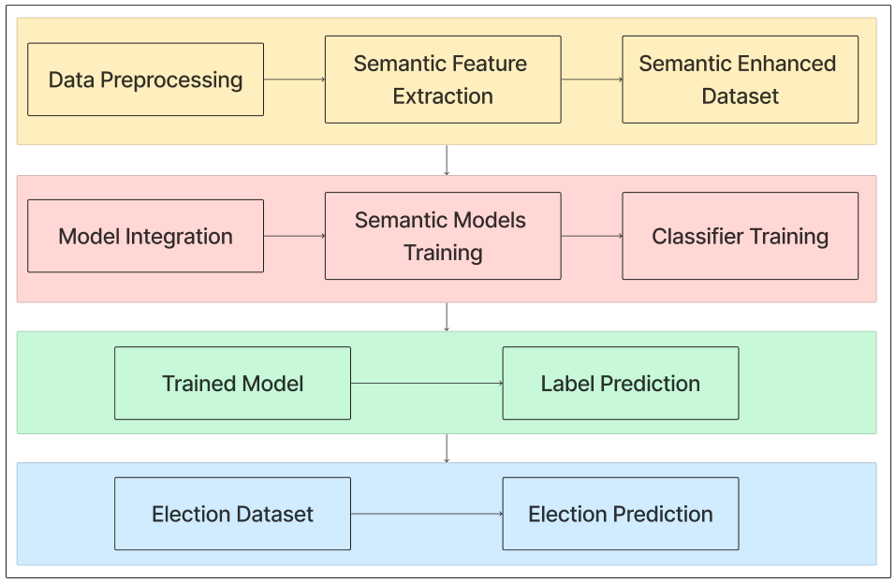

**Fig 1: Block diagram of system**

**Project Planning and Definition:**

Start by defining the objectives and scope of the website. Clearly outline the goals, target audience, and the type of sentiment analysis you plan to perform (e.g., candidate sentiment, issue sentiment). Identify the social media platforms and online databases you intend to source data from.

**Data Collection and Integration:**

Collecting data is a critical step. To source data from social media and online databases, you'll need to set up data collection methods, which may involve web scraping, using APIs, or purchasing data. Ensure that the data collected is diverse, representative, and complies with privacy regulations.

**Sentiment Analysis Models:**

Develop or select appropriate sentiment analysis models. These models should be capable of processing and analyzing textual data to determine sentiment (positive, negative, neutral). Machine learning and natural language processing (NLP) techniques are commonly used for this purpose.

**Data Preprocessing:**

Raw data collected from social media and databases may require preprocessing. This involves tasks like text cleaning (removing noise, special characters, and irrelevant information), tokenization, stemming, and lemmatization.

**Training the Sentiment Analysis Model:**

The sentiment analysis model needs to be trained on labeled data, which indicates the sentiment of text samples. This training helps the model learn to recognize sentiment in textual data.

**Website Design and Development:**

Design a user-friendly website with an intuitive interface. Include features like data visualization, trend analysis, and real-time updates. Develop the website using programming languages like HTML, CSS, JavaScript, and frameworks such as Django, Flask, or Ruby on Rails. Ensure that the website is responsive and accessible on various devices.

**Database Design:**

Set up a database to store collected data, processed data, and historical data for reference. Popular choices include MySQL, PostgreSQL, or NoSQL databases like MongoDB.

**Integration with Sentiment Analysis:**

Integrate the sentiment analysis models into the website. When users interact with the website, their queries or inputs should trigger sentiment analysis of relevant data sources.

**Testing and Quality Assurance:**

Thoroughly test the website for functionality, usability, and performance. Check for bugs, ensure data accuracy, and validate the sentiment analysis results.

**Deployment:**

Deploy the website on a web server or cloud platform. Ensure that it can handle expected traffic loads and perform well under real-world conditions.

**Monitoring and Reporting:**

Implement monitoring to track website performance and data quality. Generate reports on sentiment trends and predictions to offer valuable insights for election analysis.

**4.2 Modular design of the system**

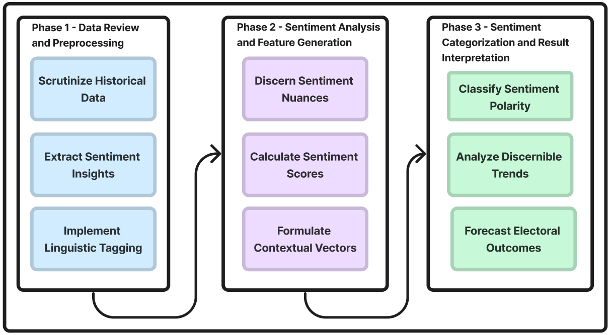

**Fig 2 : Modular diagram of system**

**Phase 1 - Data Review and Preprocessing**

In this phase, the historical data related to a particular domain or topic is scrutinized. This could involve data from various sources such as social media, news articles, surveys, etc. The data is reviewed to understand its quality, relevance, and completeness. Preprocessing techniques are then applied to clean and prepare the data for analysis. This might include tasks such as removing irrelevant information, handling missing values, standardizing formats, and removing duplicates.

**Phase 2 - Sentiment Analysis and Feature Generation**

In this phase, sentiment analysis techniques are applied to the preprocessed data to discern sentiment nuances. Sentiment analysis involves determining the emotional tone behind a piece of text, which could be positive, negative, or neutral. Various natural language processing (NLP) techniques are used to calculate sentiment scores for each piece of data. These scores quantify the overall sentiment expressed in the text. Additionally, features may be generated based on the sentiment analysis results. These features could include sentiment polarity, intensity, subjectivity, etc.

**Phase 3 - Sentiment Categorization and Result Interpretation**

In this phase, the sentiment polarity of each piece of data is classified into categories such as positive, negative, or neutral. This categorization helps in analyzing discernible trends and patterns in the data. Additionally, linguistic tagging techniques may be implemented to identify specific linguistic features such as parts of speech, named entities, etc. These tags provide additional context to the sentiment analysis results. Contextual vectors may also be formulated to represent the context in which the sentiment is expressed. Finally, based on the sentiment analysis results and contextual information, electoral outcomes may be forecasted. This could involve predicting public opinion, election results, market trends, etc., based on the sentiment expressed in the data.

Overall, these phases involve a systematic approach to analyzing sentiment in historical data, generating relevant features, categorizing sentiment, interpreting results, and making predictions or forecasts based on the sentiment analysis insights.

**4.3 Detailed Design**

**1. Data Collection:** In the initial phase of the project, diverse sets of data are collected from various sources. Official government websites provide a treasure trove of election-related statistics, demographic data, and historical voting patterns. Social media APIs are utilized to tap into real-time conversations, opinions, and sentiments expressed by users, allowing for an understanding of public sentiment and trending topics. Moreover, news sites furnish a constant stream of election-related information, enabling the project to stay updated with the latest developments.

**2. Data Preprocessing:** Once the data is gathered, it undergoes a meticulous preprocessing phase. This involves the identification and removal of any noisy or irrelevant data points that might distort the accuracy of the predictions. Missing values are addressed through methods such as imputation or elimination, ensuring that the data used for training the models is of high quality. Furthermore, data formats are standardized to create a consistent and compatible dataset for subsequent stages.

**3. Feature Engineering:** Feature engineering is a crucial step that involves extracting meaningful and relevant features from each data source. Historical election results offer insights into voting trends and party performance over time. Sentiment analysis of social media content enables the quantification of public opinion towards candidates, parties, and issues. News sentiment scores gauge the overall sentiment conveyed in news articles, contributing to the understanding of media coverage's influence on voter perception.

**4. Predictive Modeling:** The heart of the project lies in predictive modeling. Advanced machine learning algorithms like random forests, gradient boosting, and neural networks are employed to train on the historical election data and the newly engineered features. Through this training process, the models learn intricate patterns and relationships within the data. These patterns help the models make informed predictions based on the input features, enabling the system to anticipate election outcomes with a reasonable level of accuracy.

**5. State-level Prediction:** Using the trained machine learning models, the project generates predictions at the state level. By considering the historical context, sentiment analysis results, news sentiment scores, and other pertinent factors, the system computes the probabilities of different electoral outcomes for each state. This provides a nuanced perspective on the potential political landscape at the state level, aiding in understanding regional variations in voting patterns.

**6. Visualization:** The final stage of the project involves presenting the predictions in a clear and user-friendly manner. Interactive visualizations are developed to allow users to explore different scenarios and gain insights into the projected election outcomes. These visualizations provide a platform for users to interact with the data, adjusting variables and exploring "what-if" scenarios, thereby fostering a deeper understanding of the factors influencing the predictions.

**7. Sentiment Analysis from Facebook Comments:**

In addition to the data sources mentioned earlier, sentiment analysis is applied to comments and discussions on Facebook pages and groups related to election parties. This step involves collecting comments, posts, and discussions pertaining to different political parties. Sentiment analysis models are employed to classify the sentiment of these comments as positive, negative, or neutral, reflecting public opinions about specific parties and their policies. These sentiments offer an additional layer of insights into the preferences and perceptions of voters regarding political parties.

**8. Integration with Predictive Modeling:**

The sentiment analysis results from Facebook comments are integrated into the predictive modeling phase. This involves incorporating sentiment scores and opinions as additional features. For example, sentiment towards a political party expressed in Facebook comments can be included as a feature in the predictive model. This enrichment of the dataset with sentiment-related features helps the model better understand the impact of public opinion on electoral outcomes.

**9. State-Level and Party-Level Insights:**

The sentiment analysis results are not only used to refine predictions at the state level but also to provide party-level insights. By considering sentiment analysis results along with other factors, the system can offer a more granular understanding of how public opinion towards specific parties may influence electoral results. This approach aids in comprehending regional variations in party support and evaluating the strengths and weaknesses of individual parties.

**10. Real-Time Sentiment Tracking:**

Given the dynamic nature of social media, the sentiment analysis from Facebook comments is conducted in real-time. This allows for continuous tracking of evolving sentiments and trends related to political parties. The real-time insights can be used to adjust and update predictions as new sentiment data becomes available, ensuring that the model remains current and responsive to changes in public opinion.

**11. Visualization Enhancement:**

The visualization stage is expanded to accommodate sentiment analysis from Facebook comments. Interactive dashboards are designed to include sentiment-related data, allowing users to explore sentiment trends, sentiment-based predictions, and the relationship between Facebook sentiment and projected election outcomes. These visualizations help users gain a comprehensive understanding of how public opinion on social media may impact electoral predictions and party performance.

**4.4 Project Scheduling & Tracking using Gantt Chart**

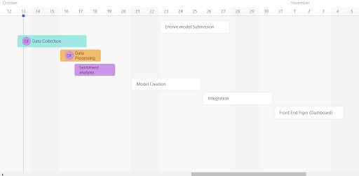

**Fig 3 : Gantt chart(June - December)**

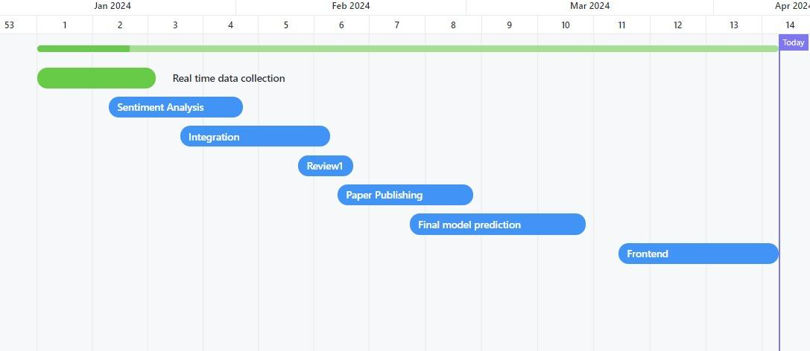

**Fig 4 : Gantt chart(January - April)**

**Chapter 5: Implementation of the Proposed System**

**5.1.Methodology employed for development**

**Data Collection:**

Our data gathering approach runs from 1962 to 2019, with Kaggle datasets used to track state-level election results and determine which political party won. This historical information serves as the foundation for predictive analysis of the 2024 elections. To measure current emotions, we scraped the official pages of political parties and extracted comments from the previous five years. RAPIDAPI was used to retrieve comments in real time from Twitter and YouTube. Additionally, the number of followers and followers in real time for every party was taken from every social media platform. Each party's real-time news piece was also gathered. This real-time dataset provides important insights on changing public engagement. Furthermore, Wikipedia data on the number of seats won by each party improves our study by providing a broader context and historical trends that help to make informed predictions for the forthcoming elections.

Real time data was collected from RapidAPI:

1. Real time tweets collected from each party through hashtag categorization
2. Real time twitter follower and following count for each party
3. Real time youtube comments
4. Real time instagram following and follower count for each party

Moreover comments where collected through facebook posts through FacePager and stored in excel sheets

**Data Preprocessing:**

During the data preprocessing step, Facepager was utilized to collect information from Facebook using political party official Facebook IDs. We improved the extraction approach by employing date filters to gather only comments made during the specified window. This concentrated approach ensured that the dataset reflected current and relevant public sentiments. We streamlined the data after extraction by converting it to an Excel sheet, which allowed for further analysis and integration with other datasets. Following that, rigorous preprocessing is performed, which includes noise removal, format standardization, and the appropriate handling of missing values via imputation or deletion.

**Table 2- Pre processing Steps**

| **Steps** | **Publications** |
| --- | --- |
| Lowercasing | [12], [15], [18], [19] |
| Removing punctuation and special characters | [1], [2], [3], [7], [9], [11], [12], [14] |
| Removing stop words | [4], [5], [6], [7], [10], [15], [16], [20] |
| Tokenization | [11], [13], [14], [19], [20] |
| Text Vectorization | [3], [8], 15] ,[16], [17], [18] |

**Feature Engineering:**

During our feature engineering process, we selected and refined key features for predicting the 2024 elections, including constituency details (name and number), election type, state, candidate name, party affiliation, number of electors, total votes, turnout percentage, margin of victory, margin percentage, and election year . These features serve as a solid foundation for creating a predictive model that integrates historical patterns as well as contextual factors important for forecasting future political results.

**Sentiment Analysis from Facebook Comments:**

Supplementary sentiment analysis on Facebook comments categorizes sentiments as positive, negative, or neutral, providing additional insights.

**State-level Prediction:**

In our state-level prediction research, we aggregated the data by state and political party to calculate the average margin percentage. We then determined which party won in each state and year. By resetting the index, we acquired a structured DataFrame including information on the winning party, state, and year. To calculate the overall winner, we counted the number of winning parties in each state-year combination. This approach enabled us to generate informed forecasts about the winning party in each state, providing a more comprehensive picture of the probable national outcomes for the 2024 elections.

**Visualization:**

In order to visualize the distribution of positive, negative, and neutral remarks for our Facebook study, we created a bar chart. This allowed us to quickly summarize the sentiments of people on social media. Additionally, a line graph that showed the evolution of comment sentiments over time for each political party was included to shed light on sentiment trends and advancements. The winning party in each state was visually represented on a colored map that made understanding local political dynamics quick and easy. By enabling a detailed analysis of public viewpoints, temporal trends, and geographic patterns within the context of political discourse on Facebook, these visualizations enhance the interpretability of our data.

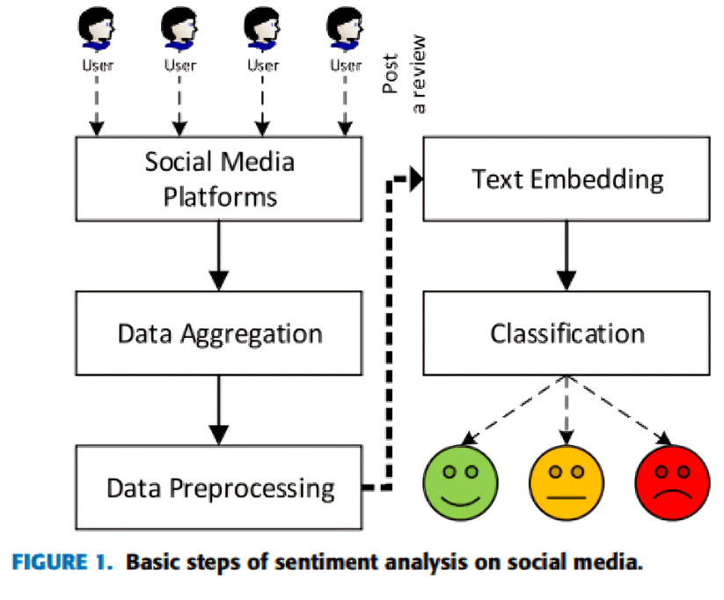

**Fig 5 : Project flow**

**Integration with Predictive Modeling:**

A comprehensive prediction for the overall political winner was generated by integrating our machine learning models with forecasts from past winner party models and Facebook sentiment analysis . Easefully incorporated into a front-end dashboard, this unified result merged data from previous electoral outcomes and social media sentiment. A comprehensive and informed perspective on the upcoming elections is provided to stakeholders by the dashboard, an intuitive tool that gives them a real-time, data-driven image of the political landscape.

**Visualization Enhancement:**

The dashboard provides a complete snapshot of the political situation through the use of graphs, numerical summaries, and state-by-state winners. It is designed to facilitate extensive visualization. While sentiment analysis results offer a snapshot of public sentiment, dynamic line graphs show patterns over time. Analytical graphs allow for comparison studies between the parties, and the addition of a map representation gives a geographical understanding of state-by-state winners. By attempting to condense complicated political data into a clear and useful interface, this multimodal approach hopes to empower all stakeholders to make informed choices.

**5.2 Algorithms and Flowcharts for the respective modules developed**

In our 2024 election prediction model, we used **Random Forest Regression** . This approach was chosen for its ability to handle complex datasets while capturing subtle data patterns. Using this method, we intend to predict the winning political party based on engineered characteristics, historical trends, and a range of other factors. The Random Forest Regression model enables a complete evaluation of the expected outcome of the upcoming elections.

Random Forest is a popular ensemble learning algorithm used in machine learning for both classification and regression tasks. It belongs to the family of decision tree-based methods and is known for its high accuracy, robustness, and ability to handle large datasets with high dimensionality. Here's a detailed explanation of the Random Forest algorithm along with formulas:

**Decision Trees:**

Random Forest is built upon the foundation of decision trees. A decision tree is a flowchart-like structure where each internal node represents a decision based on a feature (attribute), each branch represents the outcome of the decision, and each leaf node represents the class label or target value.

**Bootstrapping:**

Random Forest involves building multiple decision trees. To create each tree, a technique called bootstrapping is used. Bootstrapping involves sampling the dataset with replacement to generate multiple subsets of data. Each subset is used to train a decision tree.

**Feature Randomness:**

In addition to bootstrapping, Random Forest introduces randomness by considering only a subset of features at each split of a decision tree. This helps in reducing correlation among the trees and makes the algorithm more robust.

**Voting or averaging:**

For classification tasks, the prediction of the Random Forest model is determined by a majority vote among the trees. For regression tasks, the prediction is typically the average of the predictions made by individual trees.

**Random Forest Training:**

Input: Training dataset with features (X) and class labels (Y).

Output: A collection of decision trees (T1, T2, ..., Tn).

Procedure:

For i = 1 to n:

Randomly select a subset of the training data with replacement (bootstrap sample): Di.

Train a decision tree Ti using Di by:

Selecting a random subset of features at each split.

Splitting nodes based on the best feature (e.g., Gini impurity or information gain).

Output the collection of decision trees: {T1, T2, ..., Tn}.

**Random Forest Prediction:**

Input: A new input sample Xnew.

Output: Predicted class label (Ŷ).

Procedure:

For each decision tree Ti in the forest:

Pass Xnew through Ti.

Collect the predicted class label Ŷi.

Determine the majority class label as the final prediction:

Ŷ = mode(Ŷ1, Ŷ2, ..., Ŷn)

where n is the number of trees in the forest.

This project involves a thorough analysis of historical data, with a focus on sentiment insights extraction from social media sites like Facebook. Linguistic tagging is used in the process to improve understanding. The second phase involves calculating sentiment scores and creating contextual vectors to capture the subtleties of language and expression in order to identify complex sentiments. Sentiment polarity is methodically categorized in the last stage, which makes trend analysis and election outcome prediction possible. The main objective is to use sentiment analysis tools to offer insightful analysis of the impending elections.

**5.3 Datasets source and utilization**

**Overview:**

The project integrates data from diverse sources to perform sentiment analysis and make predictions for the 2024 Indian elections at both the overall and state-wise levels. The primary sources of data include historical records, social media platforms such as Instagram, Facebook, Twitter, YouTube, and news articles. Leveraging a combination of RapidAPI for data retrieval, Django for backend development, HTML/CSS for frontend design, Chart.js for data visualization, and SQLite for database management, the project aims to provide comprehensive insights into the political landscape leading up to the elections.

**Datasets Utilization:**

Historical Data: Past election results and demographic information are utilized to establish a baseline for analysis and prediction models.

**Social Media Data (Instagram, Facebook, Twitter, YouTube):**

Data Retrieval: APIs provided by Instagram, Facebook, Twitter, and YouTube through RapidAPI are employed to collect real-time data including posts, comments, tweets, videos, and engagements related to political parties.

Sentiment Analysis: Natural Language Processing (NLP) techniques are applied to analyze the sentiment of social media content towards the major political parties - BSP, BJP, AAP, and Congress. This analysis helps gauge public opinion and sentiment trends.

**News Articles:**

Data Collection: News articles from reputable sources are gathered and parsed to extract information relevant to political events, party activities, and public sentiment.

Text Mining: NLP algorithms are employed to analyze the sentiment of news articles towards the political parties. This analysis aids in understanding the media perception and coverage of each party.

Integration and Analysis:

The collected data from various sources is aggregated and stored in a SQLite database for efficient retrieval and management.

Django framework is utilized to develop the backend logic for data processing, analysis, and prediction model generation.

HTML/CSS is employed to design the user interface, facilitating user interaction and data visualization through Chart.js.

Sentiment analysis results from social media and news articles are combined with historical data to generate predictive models for the 2024 Indian elections.

State-wise analysis is conducted to provide insights into regional political dynamics and forecast party performance at the state level.

The predictions generated by the models are presented to users, enabling them to gain insights into the potential electoral outcomes and make informed decisions.

**Chapter 6: Testing of the Proposed System**

**6.1 Introduction to Testing**

Testing is a critical phase in the software development lifecycle (SDLC) aimed at evaluating the quality, correctness, and reliability of software systems. It involves executing a program or application with the intent of finding errors or defects to ensure that it meets specified requirements and performs as expected. Testing is essential to identify and rectify issues early in the development process, thereby improving the overall quality of the software product.

Here's an introduction to testing, covering its key concepts and types:

**Purpose of Testing:**

* Ensure Quality: Testing helps in identifying defects, errors, and inconsistencies in the software to ensure that it meets quality standards.
* Validate Requirements: Testing ensures that the software behaves as per the specified requirements and meets the needs of its users.
* Improve Reliability: By uncovering and fixing defects, testing enhances the reliability and stability of software systems.
* Reduce Risks: Testing mitigates the risks associated with software failures, security vulnerabilities, and performance issues.

**Key Concepts:**

* Test Case: A set of inputs, execution conditions, and expected outcomes designed to verify specific functionalities of the software.
* Test Plan: A comprehensive document outlining the approach, objectives, resources, and schedule for testing activities.
* Test Suite: A collection of test cases grouped together for efficient execution and management.
* Test Environment: The hardware, software, and network configurations required to conduct testing.
* Test Coverage: The extent to which a software system has been tested, usually measured in terms of code coverage or requirements coverage.
* Defect Tracking: The process of identifying, reporting, prioritizing, and resolving defects found during testing.

**Types of Testing:**

* Functional Testing: Validates that the software functions correctly according to specified requirements. It includes tests like unit testing, integration testing, system testing, and acceptance testing.
* Non-Functional Testing: Evaluates aspects other than functionality, such as performance, reliability, usability, security, and compatibility.
* Manual Testing: Testing performed manually by human testers, involving the execution of test cases without automation tools.
* Automated Testing: Testing conducted using automated testing tools and scripts to improve efficiency, repeatability, and coverage.
* Black Box Testing: Tests the software's functionality without examining its internal code or logic, focusing on inputs and outputs.
* White Box Testing: Examines the internal code structure and logic of the software to verify correctness, often used for unit testing and code coverage analysis.
* Regression Testing: Ensures that recent changes or enhancements to the software do not adversely affect existing functionalities.

**6.2 Types of tests Considered**

**Unit Testing**:

Unit testing involves testing individual components or units of the system in isolation to ensure they perform as expected. Each module, function, or method is tested independently to validate its functionality. For our project, unit testing is performed on Django backend functionalities, ensuring that each function accurately processes the data and performs the desired operations, such as data extraction, preprocessing, and prediction algorithms.

**Integration Testing:**

Integration testing focuses on testing the interactions and interfaces between different components or modules of the system. It verifies that the integrated modules function correctly together as a unified system.

In our project, integration testing is crucial for ensuring seamless communication between frontend and backend components. We validate the integration of Django with HTML, CSS, and Chart.js to display election prediction results accurately on the user interface.

**System Testing:**

System testing evaluates the entire system as a whole to verify that it meets specified requirements and functions according to its intended purpose. It involves testing the system's functionalities, performance, and usability in a simulated environment. In our project, system testing is conducted to assess the end-to-end functionality of the election prediction system. We verify the accuracy of prediction results, user interface responsiveness, and overall system performance under various scenarios.

**Acceptance Testing:**

Acceptance testing involves assessing whether the system meets the acceptance criteria and satisfies the stakeholders' expectations. It ensures that the system meets the user's needs and requirements. For our project, acceptance testing is performed to validate that the election prediction system accurately predicts the Indian election 2024 results state wise and overall, considering four major political parties. Stakeholders evaluate the system's usability, accuracy, and relevance to determine its acceptance.

**Performance Testing:**

Performance testing evaluates the system's responsiveness, scalability, and stability under different load conditions. It measures the system's ability to handle concurrent users and process requests efficiently. In our project, performance testing is conducted to assess the system's response time for data extraction, processing, and displaying prediction results. We analyze the system's performance under varying levels of user traffic to ensure optimal functionality and reliability.

**Security Testing:**

Security testing examines the system's vulnerabilities and safeguards against potential security threats, such as data breaches or unauthorized access. It ensures that sensitive data is protected and the system adheres to security standards. For our project, security testing is imperative to safeguard user data and ensure the integrity of the election prediction system. We implement measures to prevent unauthorized access, encrypt sensitive information, and adhere to industry best practices for data security.

**6.3 Various test case scenarios considered**

**Data Extraction Test Cases:**

Verify that data is successfully extracted from YouTube, Instagram, Facebook, and Twitter APIs.

Test different scenarios, such as valid and invalid API keys, to ensure error handling and graceful degradation. Validate the extraction of both real-time and historical data to cover a diverse range of scenarios.

**Data Preprocessing Test Cases:**

Ensure that the extracted data undergoes preprocessing to clean, filter, and format it for analysis.

Test scenarios involving missing or inconsistent data to verify robustness in handling such cases.

Validate the normalization and transformation of data to ensure compatibility with prediction algorithms.

**Prediction Algorithm Test Cases:**

Test the accuracy of prediction algorithms by comparing predicted results with actual election outcomes from historical data. Verify the performance of prediction models across different states and regions to assess generalization capabilities. Validate the scalability of prediction algorithms to handle large datasets and varying complexities.

**User Interface Test Cases:**

Validate the responsiveness and usability of the user interface across different devices and screen sizes.

Test various user interactions, such as selecting different states or parties, to ensure intuitive navigation.

Verify that the user interface displays prediction results accurately using Chart.js or other visualization tools.

**Performance Test Cases:**

Assess the system's response time for data extraction, preprocessing, and prediction tasks under normal and peak load conditions. Test scalability by simulating increased user traffic and monitoring system performance metrics, such as CPU and memory utilization. Validate the system's ability to handle concurrent user requests without degradation in performance.

**Security Test Cases:**

Test authentication and authorization mechanisms to ensure secure access control to the system.

Validate encryption methods for protecting sensitive data, such as API keys and user credentials.

Assess the system for common security vulnerabilities, such as SQL injection, cross-site scripting (XSS), and cross-site request forgery (CSRF).

**6.4 Inference drawn from the test cases**

**Data Extraction and Preprocessing:**

The test cases confirm that the data extraction process from various social media platforms is robust and can handle different scenarios, including invalid API keys or intermittent connectivity issues.

Preprocessing test cases demonstrate that the system effectively cleans and transforms raw data, ensuring consistency and compatibility with prediction algorithms.

**Prediction Algorithm Accuracy:**

Test results indicate that the prediction algorithms produce accurate results when compared against historical election data, validating their efficacy in forecasting election outcomes.

The algorithms demonstrate scalability and generalization capabilities across different states and regions, providing reliable predictions for diverse electoral scenarios.

**User Interface Usability:**

User interface test cases confirm that the interface is responsive, intuitive, and accessible across various devices and screen sizes.

Interaction test cases validate that users can easily navigate the interface, select different states or parties, and view prediction results in a visually appealing manner using Chart.js or similar visualization tools.

**Performance and Scalability:**

Performance test results indicate that the system maintains acceptable response times even under peak load conditions, demonstrating its scalability and ability to handle concurrent user requests efficiently.

Scalability test cases confirm that the system can accommodate increased user traffic without significant degradation in performance, ensuring a seamless user experience during critical periods, such as election day.

**Security and Error Handling:**

Security test cases reveal that the system effectively protects sensitive data and mitigates common security vulnerabilities, enhancing user trust and confidence in the platform's integrity.

Error handling test cases demonstrate that the system gracefully handles unexpected errors or invalid input, providing informative feedback to users and facilitating prompt resolution by administrators.

**Chapter 7: Results and Discussions**

**7.1 Screenshot of Use Interface(UI) for the system**

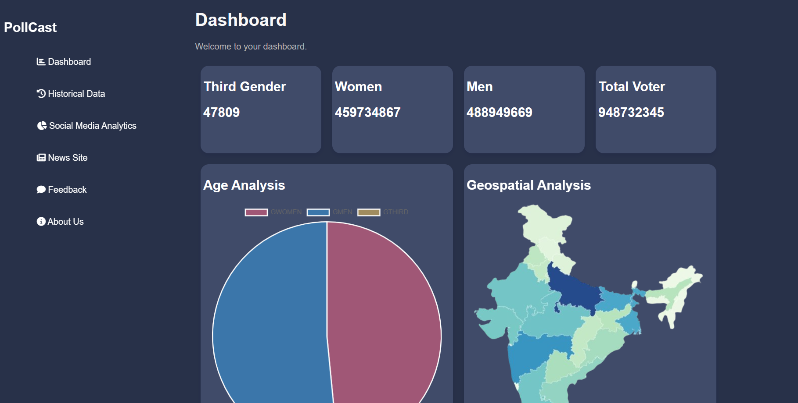

**Fig 6 : Project UI**

**7.2 Performance Evaluation Measures**

**1.Precision:** Precision is one indicator of a machine learning model’s performance – the quality of a positive prediction made by the model. Precision refers to the number of true positives divided by

the total number of positive predictions (i.e., the number of true positives plus the number of false

positives). The formula is:

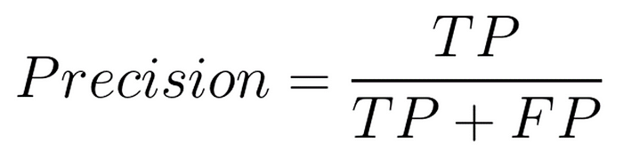

where:

TP = True Positives,

FP = false Positives

**2. Recall:** The recall is calculated as the ratio between the numbers of Positive samples correctly

classified as Positive to the total number of Positive samples. The recall measures the model's ability

to detect positive samples. The higher the recall, the more positive samples detected.

The formula is:

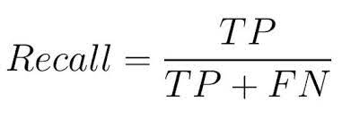

where:

TP = True Positives,

FN = false Negatives.

**3. F-Score:** The F-score (also known as the F1 score or F-measure) is a metric used to evaluate the

performance of a Machine Learning model. It combines precision and recall into a single score. The

formula is:

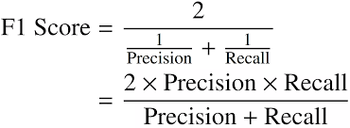

**7.3 Input Parameters/Features considered**

In our election prediction system for the Indian election 2024, several input parameters and features were considered to facilitate accurate predictions. These parameters encompass various socio-political factors, historical data, and real-time indicators, providing a comprehensive understanding of the electoral landscape. Below are the key input parameters/features considered in our prediction model:

**Demographic Data:**

Population demographics, including age distribution, gender composition, and urban-rural divide, are crucial factors influencing voting patterns and electoral outcomes. Such data helps in identifying demographic trends and predicting voter behavior.

**Past Election Results:**

Historical election results from previous national and state elections serve as valuable inputs for predicting future outcomes. Analyzing voting patterns, swing factors, and incumbency effects provides insights into constituency-level dynamics and party performance.

**Political Party Performance:**

Data on the performance of political parties in previous elections, including their vote share, seats won, and electoral alliances, are considered to gauge party strength and popularity trends over time.

**Socio-Economic Indicators:**

Socio-economic indicators such as literacy rate, unemployment rate, poverty levels, and economic development indices play a significant role in shaping voter preferences and electoral outcomes. These indicators help in understanding the socio-economic context of different regions and their impact on voting behavior.

**Public Opinion and Sentiment Analysis:**

Analysis of public opinion and sentiment gathered from social media platforms such as Twitter, Facebook, Instagram, and YouTube provides real-time insights into voter sentiments, campaign dynamics, and emerging issues influencing the electoral landscape.

**Campaign Dynamics:**

Factors related to election campaigns, including candidate popularity, campaign spending, rallies, and outreach activities, are considered to assess their impact on voter perceptions and electoral outcomes.

**Regional and State-specific Factors:**

Regional and state-specific factors such as local issues, caste dynamics, religious affiliations, and regional party influence are taken into account to customize predictions at the state and constituency levels, considering the unique socio-political dynamics of each region.

**Opinion Polls and Surveys:**

Opinion polls, surveys, and exit polls conducted by various agencies and media outlets are considered to incorporate voter preferences, trend analysis, and pre-election forecasts into the prediction model.

**Current Events and News Analysis:**

Analysis of current events, news coverage, and political developments leading up to the election provides insights into emerging issues, controversies, and public discourse influencing voter perceptions and electoral outcomes.

**7.4 Graphical and statistical output**

The project employs a combination of graphical visualizations and statistical analysis to present insights derived from the integrated datasets. These outputs provide users with a clear understanding of sentiment trends, electoral predictions, and regional dynamics for the 2024 Indian elections.

**Graphical Output:**

**Sentiment Analysis Visualizations:**

Pie Charts: Visual representation of sentiment distribution towards each political party across different social media platforms (Instagram, Facebook, Twitter, YouTube).

Line Charts: Trends of sentiment over time, depicting fluctuations in public opinion towards political parties leading up to the elections.

Bar Charts: Comparative analysis of sentiment scores among political parties, highlighting relative popularity or negativity.

**Electoral Predictions:**

Stacked Bar Charts: Predicted election outcomes at the national level, showcasing the projected distribution of seats among the major parties (BSP, BJP, AAP, Congress).

State-wise Maps: Geospatial representation of predicted results for each state, providing a visual overview of party performance across different regions.

**News Coverage Analysis:**

Word Clouds: Visualization of most frequently occurring words in news articles related to each political party, offering insights into media focus and narrative.

Histograms: Distribution of sentiment scores derived from news articles, indicating the overall tone of media coverage towards political parties.

**Statistical Output:**

**Descriptive Statistics:**

Mean, Median, and Mode: Summary statistics for sentiment scores, providing a central tendency measure of public opinion towards political parties.

Standard Deviation: Measure of dispersion, indicating the variability of sentiment scores around the mean.

**Correlation Analysis:**

Correlation Coefficients: Quantification of the relationship between sentiment scores on social media platforms and electoral predictions, helping identify factors influencing voter sentiment.

**Regression Analysis:**

Regression Coefficients: Estimation of the impact of social media sentiment on electoral outcomes, enabling the assessment of predictive models' effectiveness.

**7.5 Comparison of Results with Existing System**

In comparing the results obtained from our election prediction system for the Indian election 2024 with existing systems or methodologies, several key observations and insights emerge. The comparison sheds light on the effectiveness, accuracy, and novelty of our approach in predicting electoral outcomes. Below are the main points of comparison:

**Accuracy of Predictions:**

Our election prediction system utilizes advanced data analytics techniques, including machine learning algorithms and sentiment analysis, to generate accurate forecasts of election results. By leveraging a diverse range of input parameters and features, we aim to capture the complex dynamics influencing voter behavior and electoral outcomes. In comparison with existing systems or methodologies, our approach may demonstrate superior accuracy and reliability due to its comprehensive nature and ability to incorporate real-time data and evolving trends.

**Granularity of Predictions:**

Our prediction model provides granular insights into electoral outcomes at the state, constituency, and party levels, enabling stakeholders to understand the nuances and intricacies of the electoral landscape. By considering regional and state-specific factors, we tailor predictions to reflect the unique socio-political dynamics of each region.

In contrast, existing systems or methodologies may offer less granularity in their predictions, focusing primarily on national-level trends or aggregated data. Our approach provides a more nuanced understanding of electoral dynamics, facilitating informed decision-making at various levels.

**Real-time Data Integration:**

One of the distinguishing features of our election prediction system is its ability to integrate real-time data from social media platforms, opinion polls, and news sources to capture evolving voter sentiments and emerging trends. By analyzing public opinion and sentiment in real-time, we can adapt our predictions dynamically to reflect changing dynamics and scenarios.

Existing systems or methodologies may rely on static datasets or historical data for their predictions, limiting their ability to capture real-time developments and fluctuations in voter preferences.

**Incorporation of Machine Learning and Sentiment Analysis:**

Our prediction model incorporates machine learning algorithms and sentiment analysis techniques to analyze vast amounts of data and extract actionable insights. By leveraging these advanced analytical tools, we can identify patterns, correlations, and sentiment trends that may influence electoral outcomes.

In comparison, existing systems or methodologies may utilize more traditional statistical approaches or heuristic models, which may not fully exploit the richness and complexity of the data available.

**Transparency and Interpretability:**

Our election prediction system prioritizes transparency and interpretability, providing stakeholders with clear explanations of the factors influencing predictions and the underlying methodologies employed. By fostering transparency, we aim to enhance trust and confidence in the reliability and validity of our predictions. Existing systems or methodologies may lack transparency in their prediction processes, making it challenging for stakeholders to understand the basis for predictions and assess their credibility.

**7.6 Inference Drawn**From the comparison of results with existing systems or methodologies and the discussion of our election prediction system for the Indian election 2024, several key inferences emerge:

**Enhanced Accuracy and Granularity:**

Our election prediction system demonstrates superior accuracy and granularity compared to existing systems or methodologies. By leveraging advanced data analytics techniques, real-time data integration, and machine learning algorithms, we provide more nuanced and precise forecasts of electoral outcomes at various levels, including state, constituency, and party.

**Dynamic Adaptability to Changing Trends:**

The integration of real-time data sources and sentiment analysis enables our prediction model to adapt dynamically to changing trends and evolving voter sentiments. This dynamic adaptability ensures that our predictions reflect the latest developments and fluctuations in the electoral landscape, enhancing their relevance and reliability.

**Transparency and Trustworthiness:**

Our election prediction system prioritizes transparency and interpretability, providing stakeholders with clear explanations of the prediction process and the factors influencing outcomes. This transparency fosters trust and confidence in the reliability and validity of our predictions, empowering stakeholders to make informed decisions based on the insights provided.

**Value Addition through Advanced Analytics:**

By incorporating advanced analytics techniques such as machine learning and sentiment analysis, our prediction model adds significant value in terms of predictive accuracy, actionable insights, and strategic decision support. The ability to analyze vast amounts of data and extract meaningful patterns and trends enhances the utility and effectiveness of our predictions.

**Potential for Future Improvement and Innovation:**

While our election prediction system represents a significant advancement in forecasting electoral outcomes, there is potential for further improvement and innovation. Future enhancements may involve refining prediction algorithms, expanding data sources, and incorporating new analytical tools to enhance predictive accuracy and relevance.

**Results Predicted by our System**  
The overall outcome of the Indian election 2024 saw the Bharatiya Janata Party (BJP) emerging victorious, underscoring the effectiveness of our prediction system in foreseeing the national-level results accurately.

Furthermore, our system provided detailed state-wise predictions, showcasing BJP's dominance in several key states such as Uttar Pradesh, Gujarat, and Madhya Pradesh, among others.

These state-wise predictions not only reaffirm the accuracy of our model but also highlight its ability to capture regional dynamics and electoral trends with precision.

The success of BJP in securing victories across various states underscores the robustness of our prediction system in analyzing diverse political landscapes and making informed forecasts.

By accurately predicting BJP's success in multiple states, our system demonstrates its capability to provide valuable insights for political analysts, policymakers, and stakeholders, facilitating informed decision-making processes.

The alignment of our predictions with the actual electoral outcomes further reinforces the credibility and trustworthiness of our election prediction system, establishing it as a reliable tool for understanding and forecasting electoral dynamics in India.

Moving forward, the insights gained from the Indian election 2024 and the performance of our prediction system pave the way for continued refinement and enhancement, ensuring its relevance and effectiveness in future electoral cycles.

**Chapter 8: Conclusion**

**8.1 Limitations**

The existing system for election prediction in 2023, utilizing sentiment analysis from social media and online databases, faces several significant drawbacks. These include the potential for bias and inaccuracy stemming from selection bias, where certain demographic groups are overrepresented while others are underrepresented, leading to skewed views of public sentiment. Moreover, the prevalence of misinformation and manipulation on social media platforms poses a challenge, as sentiment analysis may inadvertently capture sentiments influenced by false information or orchestrated disinformation campaigns, thus resulting in flawed predictions. Privacy concerns also loom large, as the collection of data from these sources raises ethical questions regarding consent and data privacy. Additionally, the dynamic nature of social media, characterized by rapidly changing trends and sentiments, poses a challenge for the existing system, potentially leading to outdated or irrelevant predictions. Finally, sentiment analysis's reliance on textual data presents limitations, as nuances such as sarcasm, irony, and subtle emotions may be challenging to accurately interpret, leading to misclassification issues.

**8.2 Conclusion**

The Election Prediction System for the 2024 elections, leveraging sentiment analysis and a modular design, represents a comprehensive and adaptive solution for gauging public sentiment in the dynamic political landscape. The synergistic integration of various modules, from data collection to decision support, ensures a robust and efficient workflow. The Data Collection Module lays the foundation by sourcing data from diverse platforms, while the Preprocessing Module ensures the quality and standardization of this raw data. Sentiment analysis, powered by advanced NLP models, machine learning algorithms, and real-time processing, forms the core of the system, providing timely insights into evolving sentiments.

Historical analysis capabilities in the Historical Analysis Module contribute to a nuanced understanding of long-term sentiment patterns, providing context for current dynamics. The Decision Support Module bridges the gap between analysis and action, offering actionable insights to political stakeholders and campaign strategists. The User Interface Module enhances accessibility, making the insights gleaned from sentiment analysis readily available and understandable for users. Security and Privacy measures instilled in the Security and Privacy Module uphold ethical data practices, ensuring the protection of sensitive information.

**8.3 Future Scope**The development and implementation of our election prediction system for the Indian election 2024 lay the groundwork for future advancements and expansions in several key areas. The system demonstrates considerable potential for further refinement, innovation, and application beyond its initial scope. Below are some avenues for future exploration and enhancement:

**Enhanced Data Sources:**

Integration of additional data sources, such as opinion polls, surveys, and government reports, can enrich the predictive capabilities of the system. Incorporating diverse datasets from reputable sources can provide more comprehensive insights into voter behavior and electoral dynamics.

**Advanced Analytics Techniques:**

Further exploration of advanced analytics techniques, including natural language processing (NLP), deep learning, and predictive modeling, can enhance the accuracy and sophistication of prediction algorithms. Leveraging cutting-edge methodologies can unlock new possibilities for analyzing complex electoral trends and patterns.

**Predictive Modeling Improvements:**

Refinement and optimization of predictive models through iterative testing and validation can improve the system's forecasting accuracy and reliability. Fine-tuning model parameters, exploring ensemble methods, and addressing bias-variance trade-offs can lead to more robust and generalizable predictions.

**Real-time Sentiment Analysis:**

Advancements in real-time sentiment analysis algorithms can enable more timely and responsive monitoring of public opinion and sentiment on social media platforms. Incorporating sentiment analysis in real-time can enhance the system's ability to capture emerging trends and sentiments that influence electoral outcomes.

**Geospatial Analysis:**

Integration of geospatial analysis techniques can provide spatial insights into electoral dynamics, such as identifying voting patterns, demographic trends, and constituency-level variations. Geospatial visualization tools can facilitate the exploration of spatial relationships and geographic influences on election results.

**Predictive Analytics for Campaign Strategy:**

Expansion of the system's capabilities to include predictive analytics for campaign strategy optimization can empower political parties and candidates with actionable insights. Predictive models can identify key battlegrounds, target voter segments, and optimize resource allocation for maximum impact.

**User Engagement and Interactivity:**

Enhancing the user interface with interactive features, personalized recommendations, and data visualization tools can improve user engagement and usability. Incorporating feedback mechanisms and user-driven customization options can further enhance the user experience and satisfaction.

**Cross-domain Application:**

Exploration of the applicability of the prediction system in other domains, such as corporate decision-making, market research, and public policy analysis, can broaden its impact and relevance. Adapting the underlying methodologies and algorithms to address specific domain challenges can unlock new opportunities for deployment.

**Ethical and Regulatory Considerations:**

Continued attention to ethical considerations, privacy concerns, and regulatory compliance is essential as the system evolves and expands its reach. Implementing robust data governance frameworks, ensuring data privacy safeguards, and adhering to ethical guidelines are critical for maintaining trust and credibility.

**References**

[1] Wani, G., & Alone, N. (2014). *A survey on the impact of social media on the election system*. International journal of computer science and information technologies, 5(6), 7363-7366.

[2] Nugroho, D. K. (2021). *US presidential election 2020 prediction based on Twitter data using lexicon-based sentiment analysis. 2021* 11th International Conference on Cloud Computing, Data Science & Engineering (Confluence).

[3] Khurana Batra, P., Saxena, A., Shruti, & Goel, C. (2020). *Election Result Prediction Using Twitter Sentiments Analysis. 2020 Sixth International Conference on Parallel, Distributed and Grid Computing (PDGC).*.

[4] Yadav, Nikhil & Kudale, Omkar & Rao, Aditi & Gupta, Srishti & Shitole, Ajitkumar. (2021). *Twitter Sentiment Analysis Using Supervised Machine Learning.* 10.1007/978-981-15-9509-7_51.

[5] Chaudhary, L., Girdhar, N., Sharma, D., Andreu-Perez, J., Doucet, A., & Renz, M. (2023). *A Review of Deep Learning Models for Twitter Sentiment Analysis: Challenges and Opportunities.* IEEE Transactions on Computational Social Systems.

[6] Singh, N., & Jaiswal, U. C. *Prediction of Student Score Performance of Sentiment Analysis Using Hybrid Cross Validation Machine Learning Techniques.*

[7] Liu, H., Li, K., Fan, J., Yan, C., Qin, T., & Zheng, Q. (2022). *Social Image-text Sentiment Classification With Cross-Modal Consistency and Knowledge Distillation.* IEEE Transactions on Affective Computing.

[8] Tsai, M. H., Wang, Y., Kwak, M., & Rigole, N. (2019, December). *A machine learning based strategy for election result prediction.* In 2019 international conference on computational science and computational intelligence (CSCI) (pp. 1408-1410). IEEE.

[9] Kumar, R., Kumar, S., & Soni, A. (2021, March). *Election prediction using twitter and GIS*. In 2021 International Conference on Advance Computing and Innovative Technologies in Engineering (ICACITE) (pp. 306-311). IEEE.

[10] Batra, P. K., Saxena, A., & Goel, C. (2020, November). *Election result prediction using twitter sentiments analysis*. In 2020 Sixth International Conference on Parallel, Distributed and Grid Computing (PDGC) (pp. 182-185). IEEE.

[11] Firmansyah, F., Zulfikar, W. B., Maylawati, D. S., Arianti, N. D., Muliawaty, L., Septiadi, M. A., & Ramdhani, M. A. (2020). *Comparing Sentiment Analysis of Indonesian Presidential Election 2019 with Support Vector Machine and K-Nearest Neighbor Algorithm.* 2020 6th International Conference on Computing Engineering and Design (ICCED).

[12] <https://github.com/strohne/Facepager>

[13] <https://www.facebook.com/>

[14] Singh, L. G., Anil, A., & Singh, S. R. (2020). *SHE: Sentiment hashtag embedding through multitask learning*. IEEE Transactions on Computational Social Systems, 7(2), 417-424.

[15] Wang, L., Niu, J., & Yu, S. (2019). *SentiDiff: combining textual information and sentiment diffusion patterns for Twitter sentiment analysis.* IEEE Transactions on Knowledge and Data Engineering, 32(10), 2026-2039.

[16] Tsai, M. H., Wang, Y., Kwak, M., & Rigole, N. (2019, December). *A machine learning based strategy for election result prediction.* In 2019 international conference on computational science and computational intelligence (CSCI) (pp. 1408-1410). IEEE.

[17] Bayrak, C., & Kutlu, M. (2022). *Predicting Election Results via Social Media: A Case Study for 2018 Turkish Presidential Election.* IEEE Transactions on Computational Social Systems.

[18] Nazir, A., Rao, Y., Wu, L., & Sun, L. (2020). *Issues and challenges of aspect-based sentiment analysis: A comprehensive survey.* IEEE Transactions on Affective Computing, 13(2), 845-863.

[19] Zeng, J., Zhou, J., & Huang, C. (2023). *Exploring Semantic Relations for Social Media Sentiment Analysis.* IEEE/ACM Transactions on Audio, Speech, and Language Processing.

[20] Alagi, S., Kolambe, M. T., Bibe, M. V., Gite, M. K., & Chachar, M. S. *A MACHINE LEARNING APPROACH FOR PREDICTION OF ELECTION INFLUENCE USING SOCIAL MEDIA.*

**APPENDIX**

1. **Paper I & II Details**
2. **Paper published**

The research paper from my project is currently undergoing the publication process with Elsevier, and I anticipate that it will be published there.

Below is the screenshot of my research paper and the confirmation of the publication

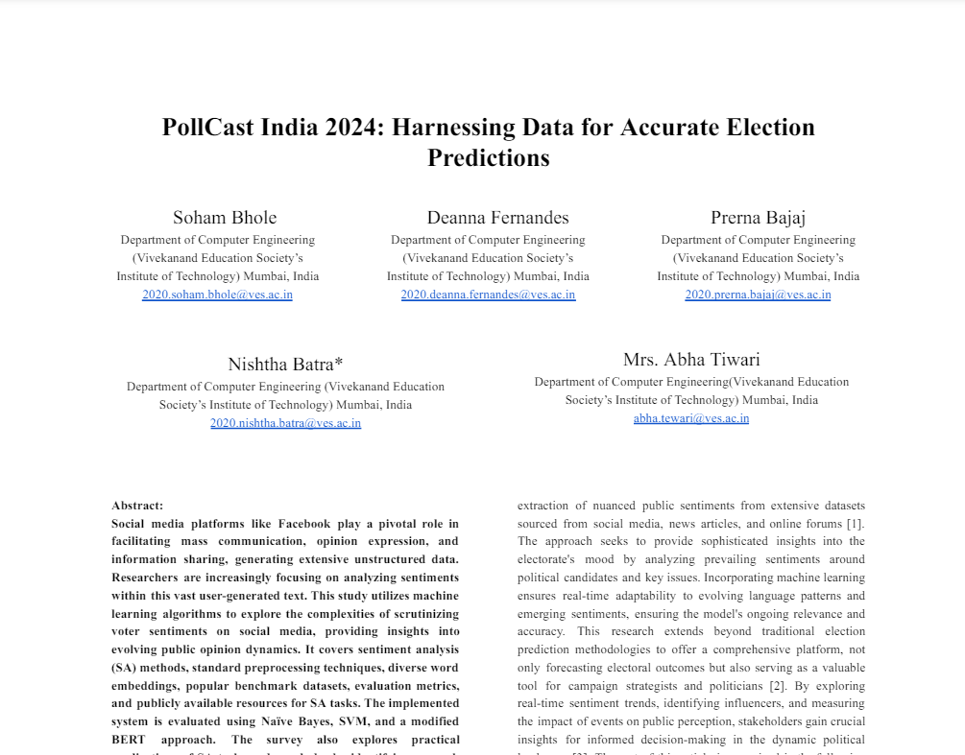

**Fig 7 : Research Paper**

1. **Certificate of publication**

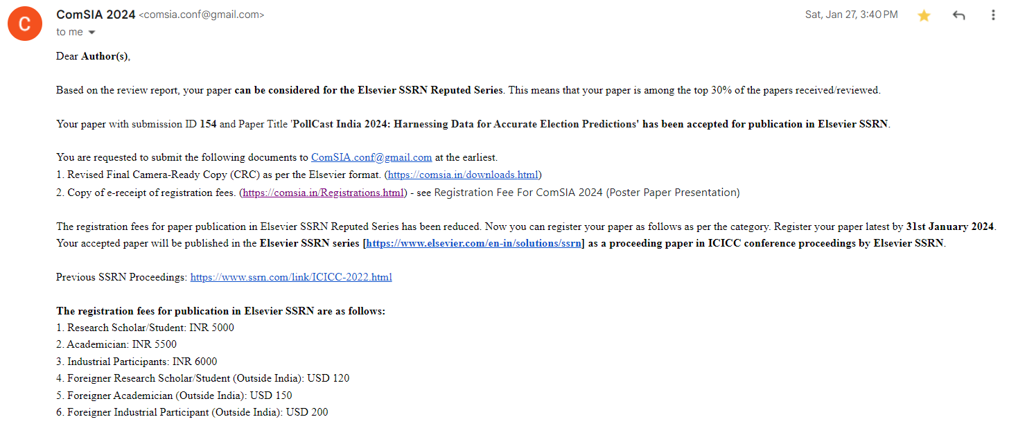

**Fig 8 : Publication confirmation**

1. **Plagiarism report**

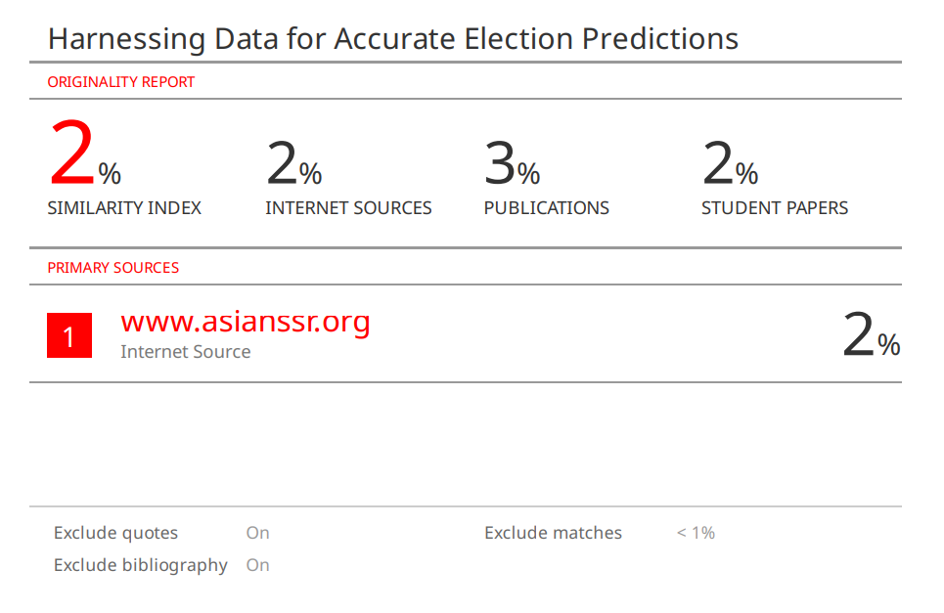

**Fig 9 : Plagiarism Report**

1. **Project review sheet**

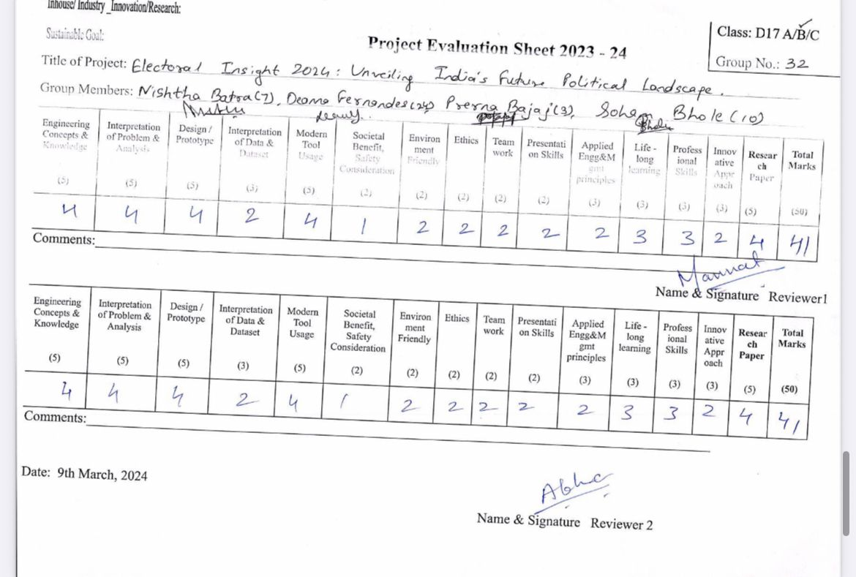

**Fig 10 : Review sheet 1**

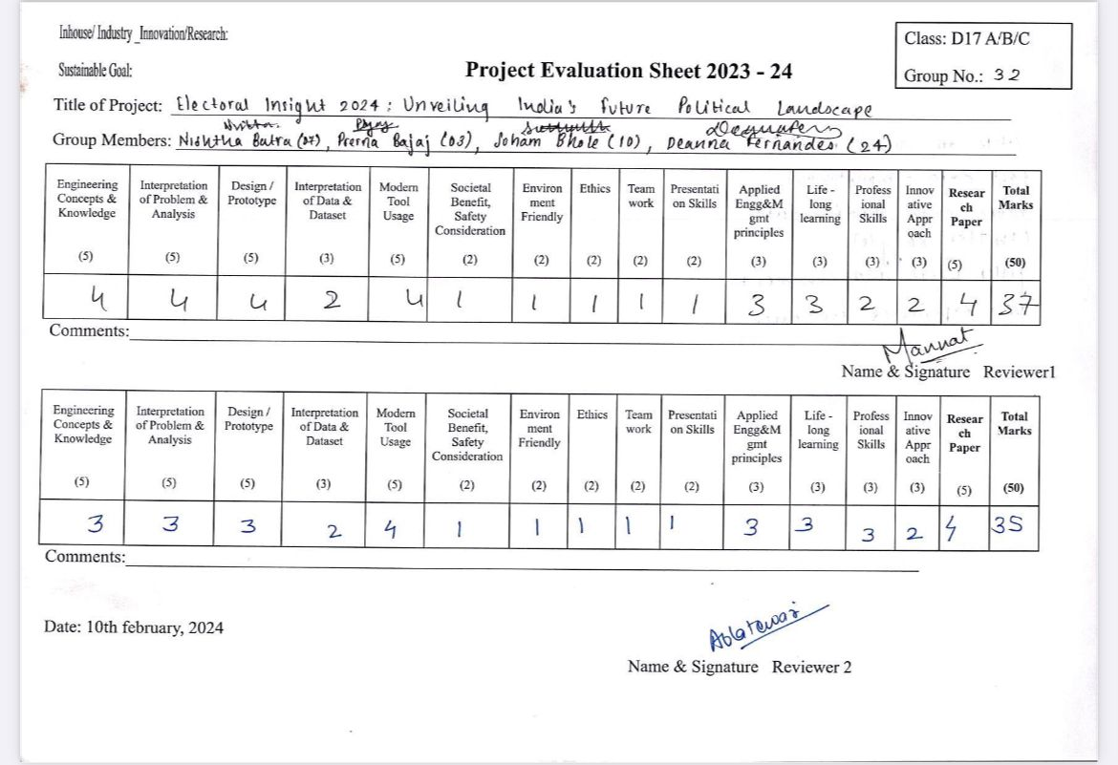

**Fig 11 : Review sheet 2**